

BRACT’s Vishwakarma Institute of Information Technology

**PROJECT REPORT ON**

**Online Examination System**

DEPARTMENT OF COMPUTER SCIENCE AND ENGINEERING

(ARTIFICIAL INTELLIGENCE)

|  |  |  |
| --- | --- | --- |
| **Sr No.** | **Name** | **Email Id** |
| ,.1 | Sarthak Rathi | sarthak.22320208@viit.ac.in |
| 2 | Pallavi Kanawade | pallavi.22320177@viit.ac.in |
| 3 | Khushi Sanjay Agrawal | khushi.22320215@viit.ac.in |
| 4 | Chaitanya Prashant Unavane | chaitanya.22320221@viit.ac.in |

Under Guidance of

Dr. Anuradha Yenkikar, Prof. Pradnya Mehta, Prof. Pranjal Pandit

**Contents**

Abstract: 2

Introduction: 2

Objective: 3

Proposed Methodology: 4

System Specification: 5

Entity Relationship Diagram: 6

UML Diagram: 6

Screenshots Of GUI: 10

Conclusion: 14

Reference: 14

## **Abstract:**

Online Examination System is designed and developed for Students and Professor. The platform facilitates online examinations for students. This system enables students to complete their exams remotely via the internet. The application is built using React.js for the front end and utilizes a database for storing and managing data. The current system faces a significant challenge as students still undergo manual examination processes. This antiquated approach leads to inefficient time utilization, with the manual procedures for exam administration consuming considerable time. Lecturers spend extra time distributing question papers and answer sheets, while students require additional time to complete their exams in writing. Therefore, there is a pressing need to modernize the system to streamline these processes and enhance efficiency. Our system platform serves as a versatile solution engineered to streamline the management of multiple-choice question exams effortlessly. It offers various functionalities tailored to meet the diverse needs of exam administration, ensuring a smooth and efficient process.

## **Introduction:**

Our project introduces an innovative Online Examination System utilizing the dynamic capabilities of React.js for frontend development and the robust data management features of SQL. This system revolutionizes traditional examination processes, offering a seamless and efficient solution that enhances accessibility, scalability, and security.

React.js powers the frontend interface of our Online Examination System, ensuring a responsive and intuitive user experience for administrators, instructors, and students alike. Through its modular and component-based architecture, React.js facilitates dynamic content rendering and interactive user interactions, optimizing usability and engagement.

At the heart of our Online Examination System lies a powerful database management system built on SQL technology. SQL enables secure storage, retrieval, and manipulation of examination-related data, including student profiles, exam questions, and performance metrics. Leveraging SQL ensures data integrity, confidentiality, and compliance with data protection regulations.

Together, React.js and SQL form a formidable combination that drives the functionality and efficiency of our Online Examination System. By harnessing the strengths of these technologies, we deliver a comprehensive solution that empowers educational institutions with a scalable, secure, and user-centric platform for conducting online assessments.

In addition to its robust features, our Online Examination System is equipped with advanced security measures to prevent cheating and ensure the integrity of the assessment process. Our system incorporates measures to prevent copying of questions and prohibits tab switching during exams, thereby minimizing the risk of unauthorized access to external resources and maintaining a fair and transparent examination environment. give in another sentences.

## **Objective:**

To revolutionize the examination process through the development of an advanced Online Examination System, our objective is to prioritize accessibility, security, and integrity. Our primary focus is on preventing plagiarism and tab switching, ensuring academic honesty. We aim to achieve this by implementing sophisticated error detection mechanisms that promptly alert users and limit exam termination after three consecutive incidents. Additionally, we aim to empower educators with intuitive interfaces and actionable insights for continuous improvement in teaching and learning outcomes. By seamlessly integrating these features, we aspire to redefine the assessment experience, fostering a fair and transparent environment that instills confidence in educators and students alike."

## 

## **Proposed Methodology:**

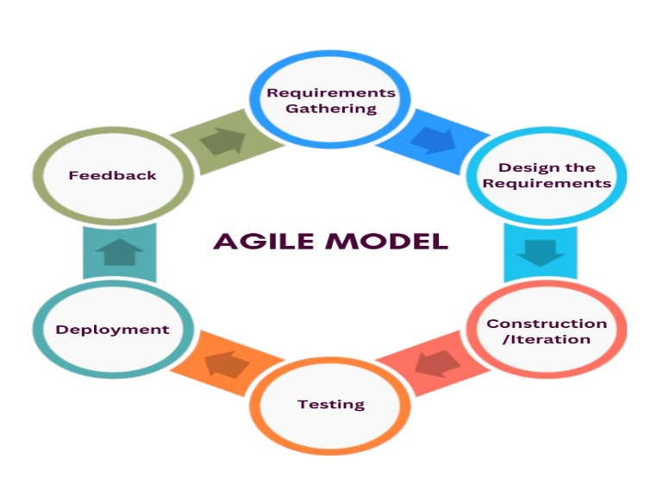The integration of Agile and Waterfall methodologies in the development of the Online Examination System enables a structured yet flexible workflow, allowing for continuous feedback loops and iterative improvements throughout the development lifecycle.

Agile is a project management methodology focused on flexibility, collaboration, and responsiveness. It emphasizes iterative development, early delivery, and continuous improvement. Agile prioritizes teamwork, customer collaboration, and adaptability to change, enabling teams to deliver high-quality products efficiently.

**Collaborative Brainstorming and Planning:**

Form a collaborative group with peers interested in the project, each contributing their unique skills and perspectives.

Brainstorm ideas collectively for the Online Examination System and establish clear objectives and goals for the project.

**Requirement Gathering and Analysis:**

Engage with fellow students, instructors, and educational staff to gather requirements and understand their needs for the system.

Analyze and prioritize requirements together as a team, considering the feasibility and relevance of each feature.

**Joint Design and Prototyping**:

Collaborate on designing the system's architecture, user interface, and user experience.

Create rough sketches or wireframes collaboratively to visualize the layout and flow of the system.

**Divided Development Tasks:**

Assign development tasks among team members based on their strengths and interests.

Work collaboratively on developing the frontend using technologies like React.js and the backend using languages like MySQL.

**Testing and Peer Review:**

Conduct thorough testing of each component of the system, with team members reviewing each other's work.

Provide constructive feedback and support to address any issues or bugs identified during testing.

**Deployment and Feedback Collection:**

Deploy the system to a test environment accessible to fellow students for feedback and testing.

Gather feedback from users through discussions, surveys, or feedback forms, involving the entire team in the feedback collection process.

**Continuous Improvement:**

Use feedback from users to iteratively improve the system, with the team collaborating on implementing enhancements and addressing any identified issues.

Encourage open communication and collaboration among team members to foster a culture of continuous improvement.

**Support and Maintenance:**

Provide ongoing support and maintenance for the system, with team members working together to address any user inquiries or technical issues.

## **System Specification:**

* Hardware Requirements

1. The Software is developed in the system having following configuration.
2. Processor: 11th Gen Intel® Core™ i5-1135G7 @ 2.40GHz
3. 2.42GHz Ram: 8G
4. Solid State Drive: 512GB

* System Requirements

1. Front End: React.js
2. Back End: My SQL.
3. Operating System: Windows

## **Entity Relationship Diagram:**

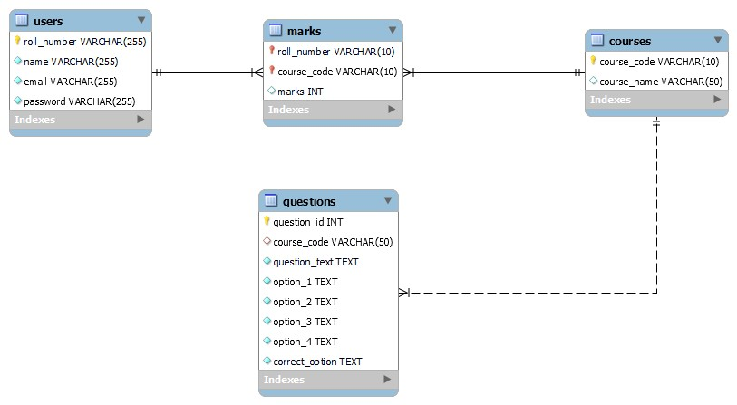

**Fig: 01 Entity Relationship Diagram**

## **UML Diagram:**

**Levels in Data Flow Diagrams (DFD)**

**0-level DFD:**

It is also known as context diagram. It’s designed to be an abstraction view, showing the system as a single process with its relationship to external entities. It represents the entire system as single bubble with input and output data indicated by incoming/outgoing arrows.

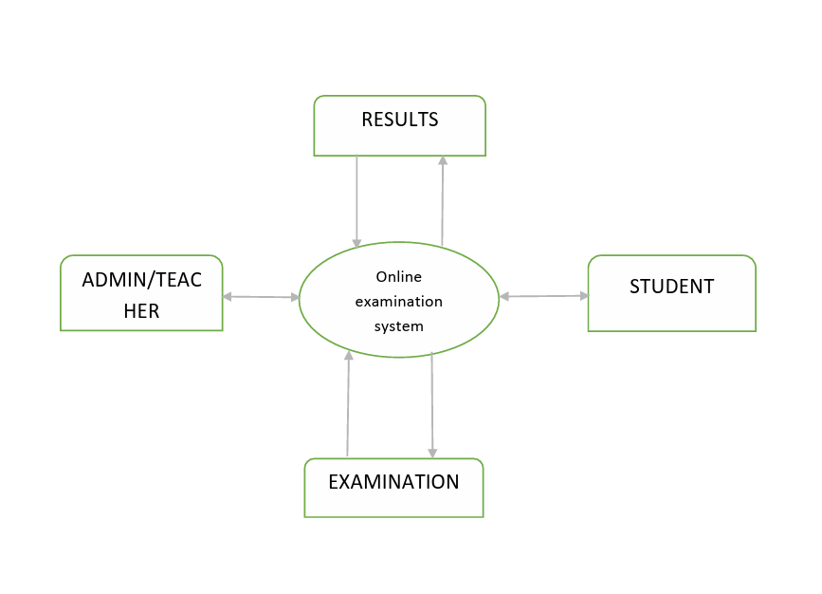

**Fig:02 Level-0 DFD**

**1-level DFD:**

In 1-level DFD, context diagram is decomposed into multiple bubbles/processes. in this level we highlight the main functions of the system and breakdown the high-level process of 0-level DFD into sub processes.

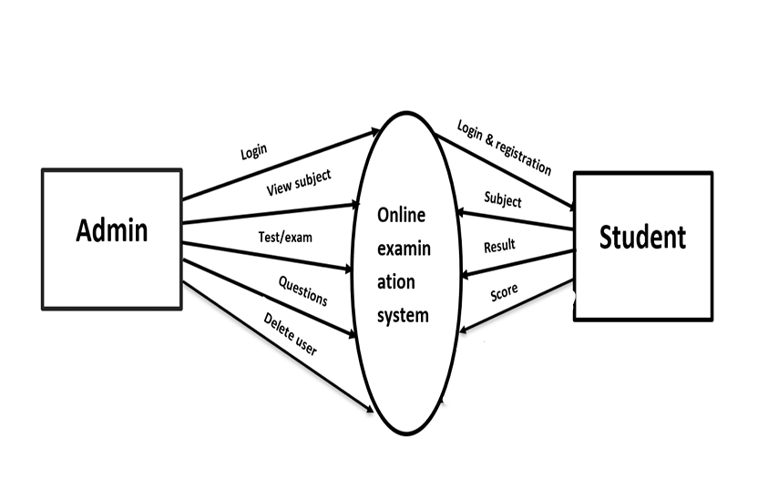

**Fig: 03 Level-01 DFD**

**2-level DFD:**

2-level DFD goes one step deeper into parts of 1-level DFD. It can be used to plan or record the specific/necessary detail about the system’s functioning.

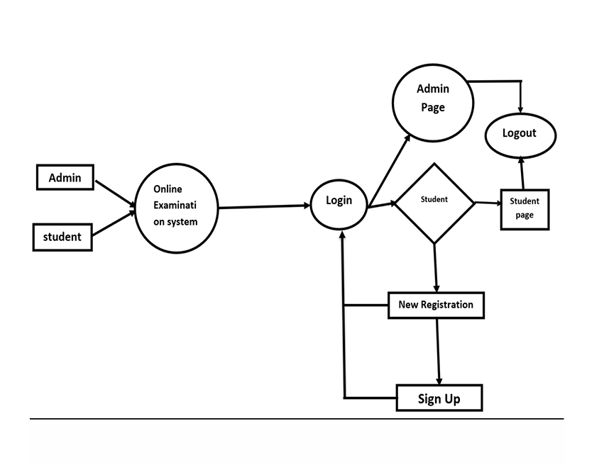

**Fig: 04 Level-02 DFD**

**USE-CASE Diagram:**

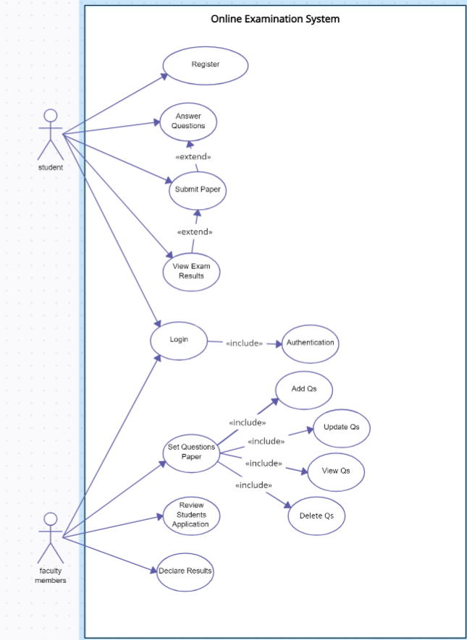

**Fig: 05 Use-Case Diagram**

**Sequence Diagram:**

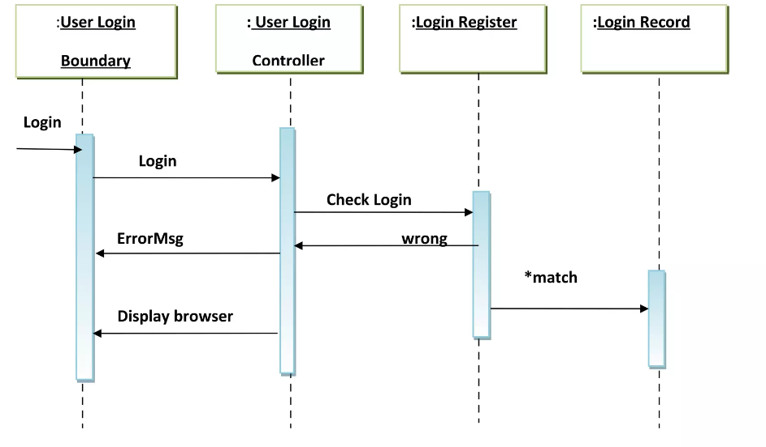

**Fig:-06 Sequence Diagram**

## **Screenshots Of GUI:**

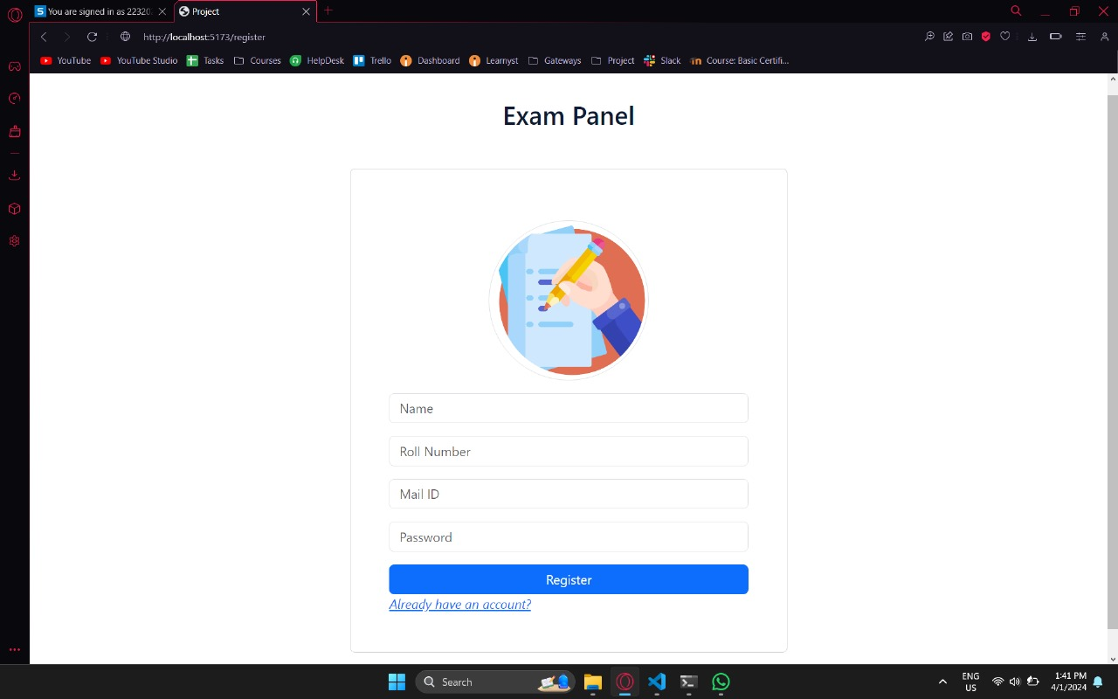

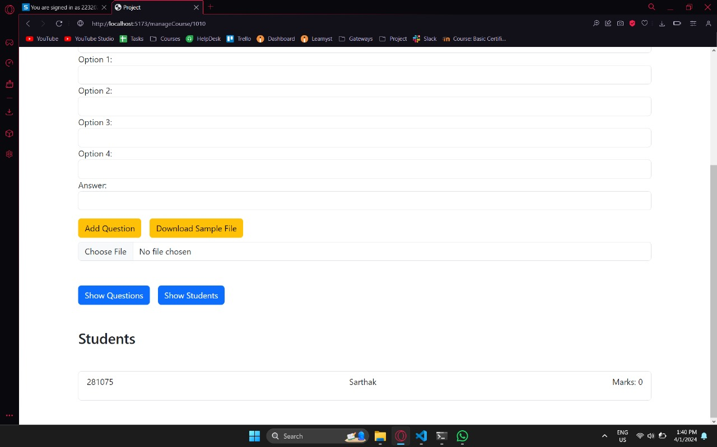

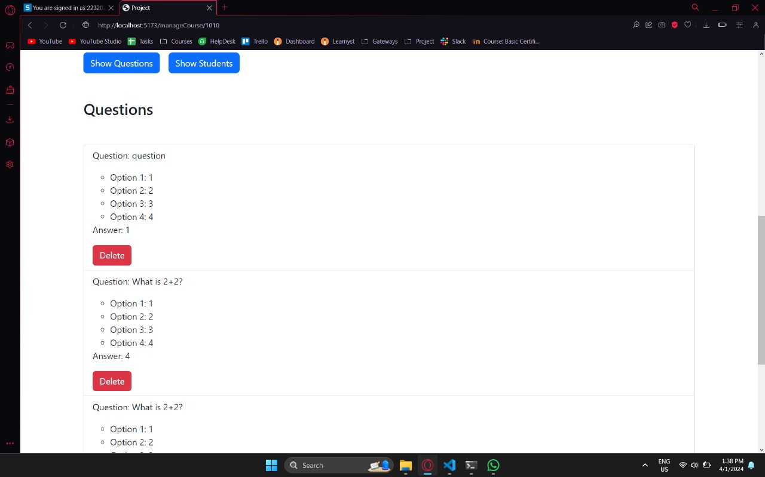

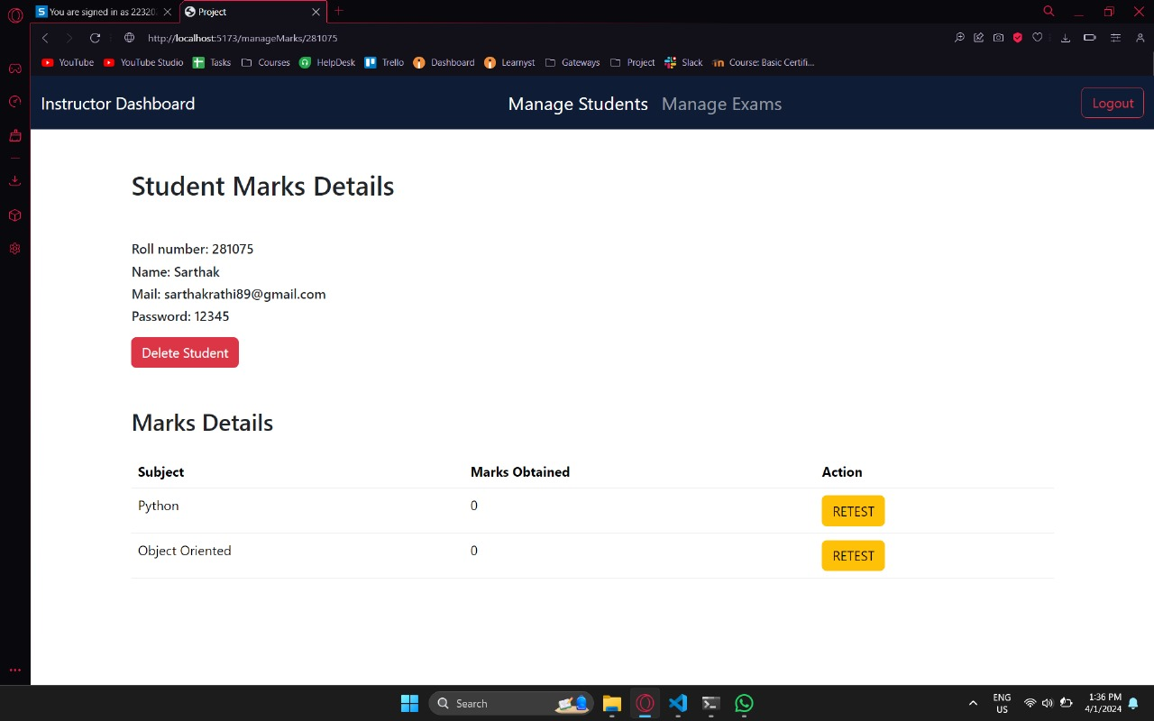

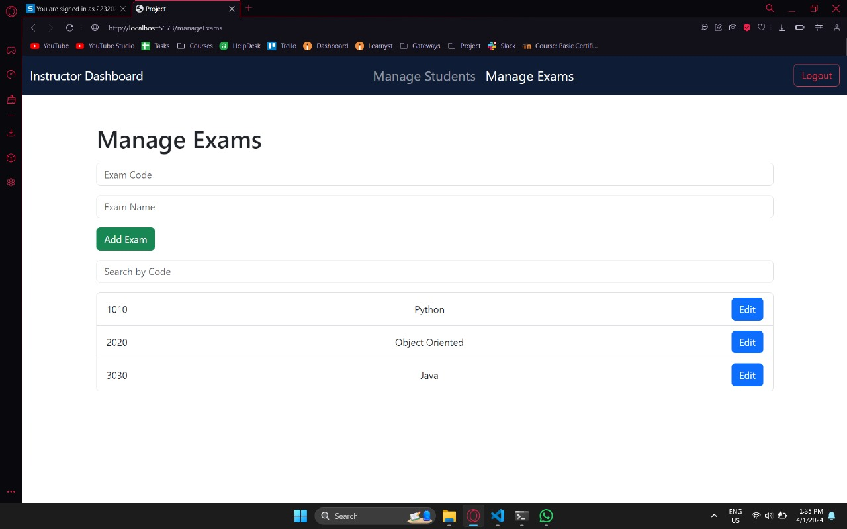

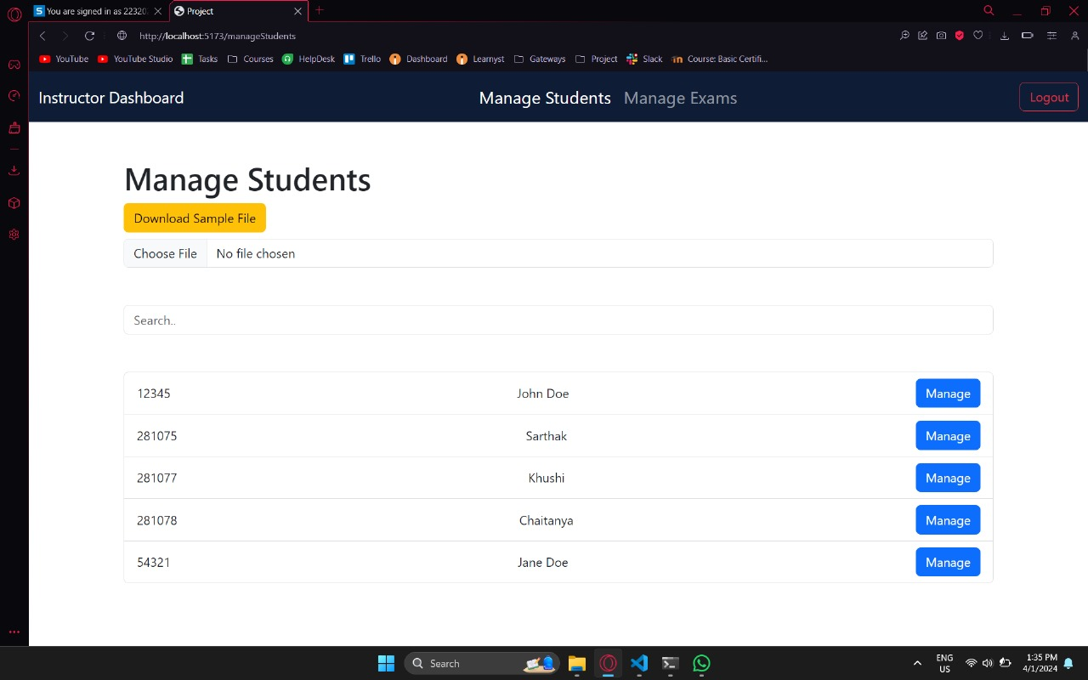

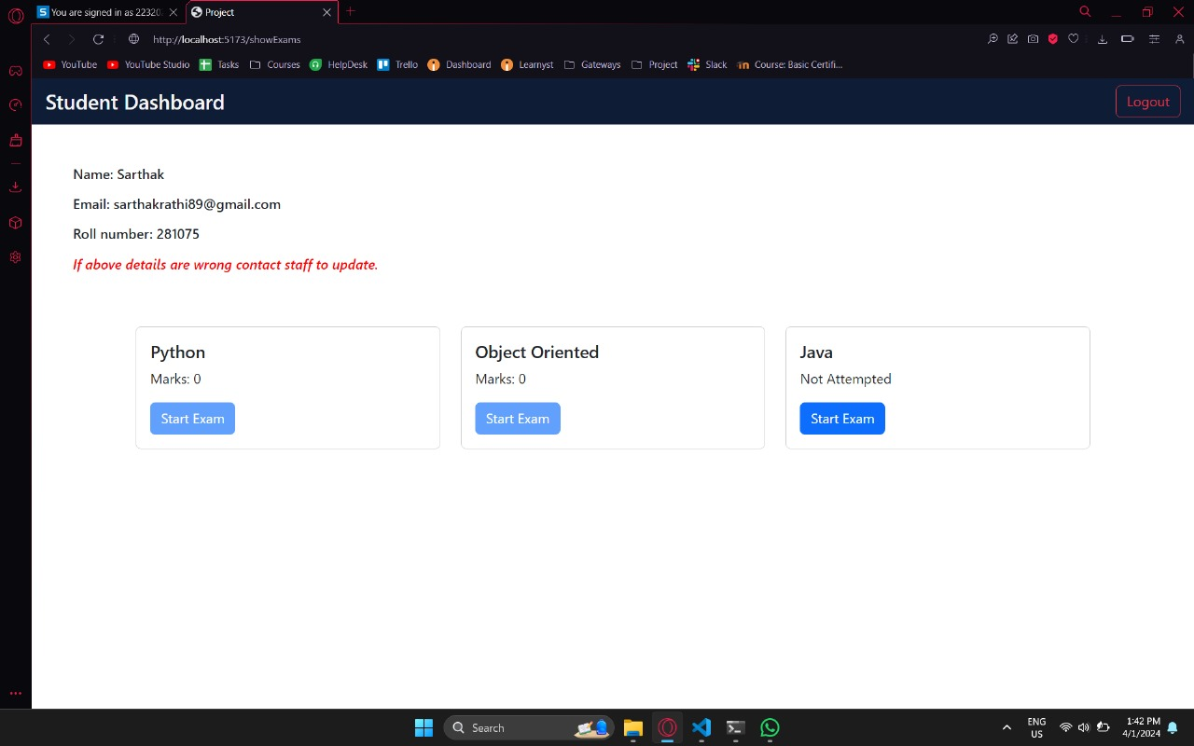

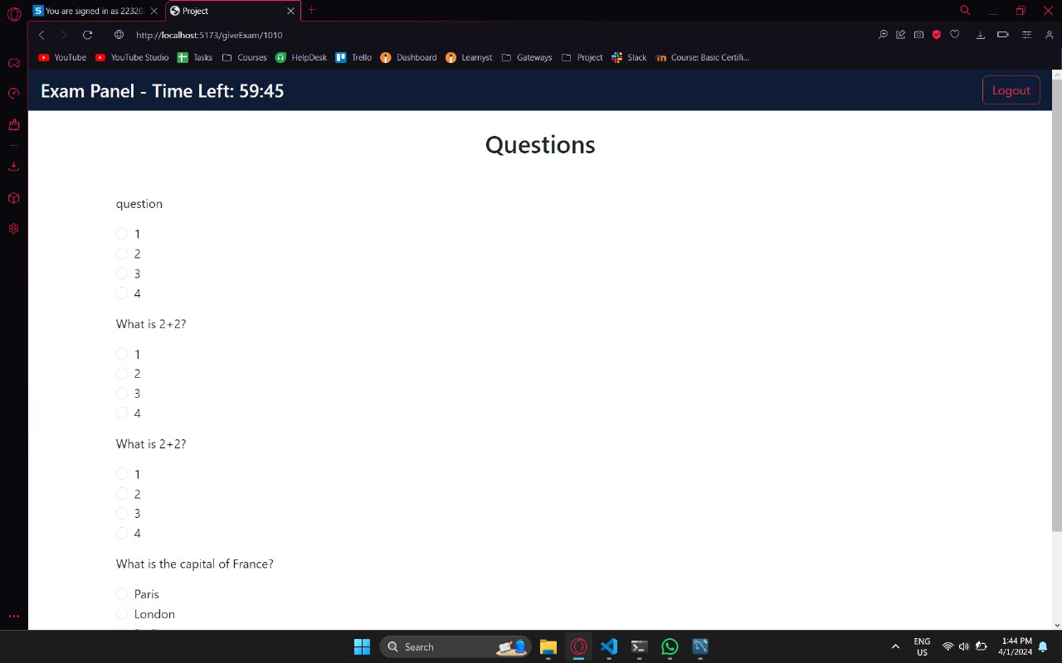

## **Conclusion:**

In essence, our Online Examination System revolutionizes the testing landscape. It boasts unparalleled ease of use, ensuring a seamless experience for both educators and students alike. By incorporating cutting-edge technologies like React.js and SQL, it not only simplifies exam administration but also ensures fairness and adaptability to individual needs. Teachers find it a breeze to manage exams, while students appreciate its user-friendly interface and flexible features. Moreover, its continuous improvement ensures that education stays at the forefront of progress. In just a few clicks, exams become more efficient, transparent, and tailored to the modern learning environment. With our system, the journey of education is propelled forward, shaping a brighter future for all involved**.**

## **Reference:**

1. [**https://www.researchgate.net/publication/317306939_Online_Examination_System**](https://www.researchgate.net/publication/317306939_Online_Examination_System)
2. [**http://ieeexplore.ieee.org/abstract/document/7429241/**](http://ieeexplore.ieee.org/abstract/document/7429241/)
3. [**https://www.ijraset.com/research-paper/paper-on-online-examination-system**](https://www.ijraset.com/research-paper/paper-on-online-examination-system)
4. [**https://www.ncbi.nlm.nih.gov/pmc/articles/PMC7508171/**](https://www.ncbi.nlm.nih.gov/pmc/articles/PMC7508171/)
5. [**https://www.sciencegate.app/keyword/3385841**](https://www.sciencegate.app/keyword/3385841)